Math 10

Lesson 2-5 Love those polynomials

Lesson Objectives:
a) To practice multiplying and factoring polynomials and solving problems that involve polynomials.

Assignment – part A
Directions:
- All work must done on a separate sheet of paper.
- Factor each question completely.
- Check 5 of the following questions! (Whichever 5 you want)
- If the expression doesn’t factor, write: DNF and briefly explain why.

1. | 12a³b⁷ + 4a²b⁵ – 8ab² | 21. | x²(x² – 4) + 4x(x² – 4) + 4(x² – 4)
2. | 5c³d + 70c²d² + 60cd³ | 22. | x² – 10x – 11
3. | 27x² – 300 y² | 23. | j² – 169
4. | n² – 13np + 30p² | 24. | 7y(y + 3x) + 2x(3x + y)
5. | x⁴ – 2x² + 1 | 25. | (a + 5x)² – 49x²
6. | 3x² + 5x – 2 | 26. | 6x³ + 3x² – 10x – 5
7. | 18x⁴y³ + 9x³y⁴ – 3x³y³ | 27. | 12a² – 7ab + b²
8. | (3w – 5)² – (w + 7)² | 28. | 81b² – 64
9. | d² + 6d + 9 | 29. | 8(5x² + 3y – 1) – x(5x² + 3y – 1)
10. | 9x² – ¼y² | 30. | n² + 4
11. | 45x³y + 35x²y² – 10xy³ | 31. | 2x⁴ + 10x² + 72
12. | 5ab + 9b² + 45ab | 32. | 16x² – 1
13. | x² + x + 20 | 33. | 3m³ + 21m²n + 4m + 28n
14. | x² + 10x – 11 | 34. | –3y² + 75y + 162
15. | r²s + 3rs² + 2s³ | 35. | 6w³ –28w² + 30w
16. | x² + 4x + 5 | 36. | 6c² – cd – 12d²
17. | 10st + 15t | 37. | 4x² + 20x + 25
18. | 7w(x – w) – 10(w – x) | 38. | 25x² – 20xy + 4y²
19. | x⁴ – 625 | 39. | 4mn² – 4m²n² + m³n²
20. | 3a² – 10ab – 8b² | 40. | 18x + 12x² + 2x³

Assignment – part B
1. The total revenue from sales of ski jackets can be modelled by the expression Revenue = 720 + 4x – 2x², where x represents the number of jackets sold above the minimum needed to break even. Revenue is also calculated as the product of the number of jackets sold and the price per jacket. Factor the given expression to determine the number sold and the price per jacket. The minimum price of a jacket is $18. Hint: As the price increases, the number sold decreases.

2. A square has an area of 9x² + 30xy + 25y² square centimetres. What is the perimeter of the square?

3. The area of a certain shape can be represented by the expression 8x² + 10x – 7.
a) Identify a possible shape.
b) Write expressions for the possible dimensions of the shape you identified in part a).

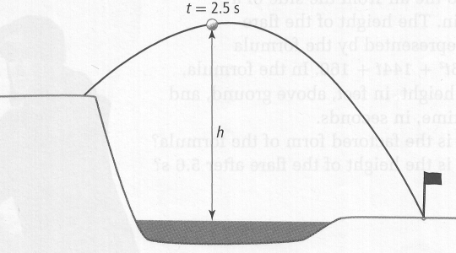
4. The world famous Devil's Cauldron is the 4th hole at the Banff Springs Golf Course. This is a tough tee shot from an elevated tee that must carry the ball across a glacial lake to a small bowl green. The approximate height of the ball during a typical shot can be represented by the formula
h = –5t² + 25t + 30
where t is the time, in seconds, and h is the height of the ball relative to the green, in metres.
a) Write the formula in factored form.
b) What is the height of the golf ball after 2.5 s?

